# **Name: Abdurrahman Qureshi**

# **Roll No: 242466**

Practical No: 1

**1)** Create a SQL query to define two tables: emp and dept, with the following conditions:

The emp table should have the columns: id, name, dept_no, job, and hire_date.

* id should be the Primary Key and must not allow null values.
* job should only contain uppercase entries.
* hire_date should default to the current date.
* All other columns should not allow null values.

The dept table should have the columns: dept_no, dname, and loc.

* dept_no should be the Primary Key.
* The dname and loc columns should not allow null values.

QUERY:

CREATE TABLE emp (

id INT PRIMARY KEY,

name VARCHAR(100) NOT NULL,

dept_no INT NOT NULL,

job VARCHAR(50) NOT NULL CHECK (job = UPPER(job)),

hire_date DATE DEFAULT CURRENT_DATE

);

CREATE TABLE dept (

dept_no INT PRIMARY KEY,

dname VARCHAR(100) NOT NULL,

loc VARCHAR(100) NOT NULL

);

**OUTPUT:**

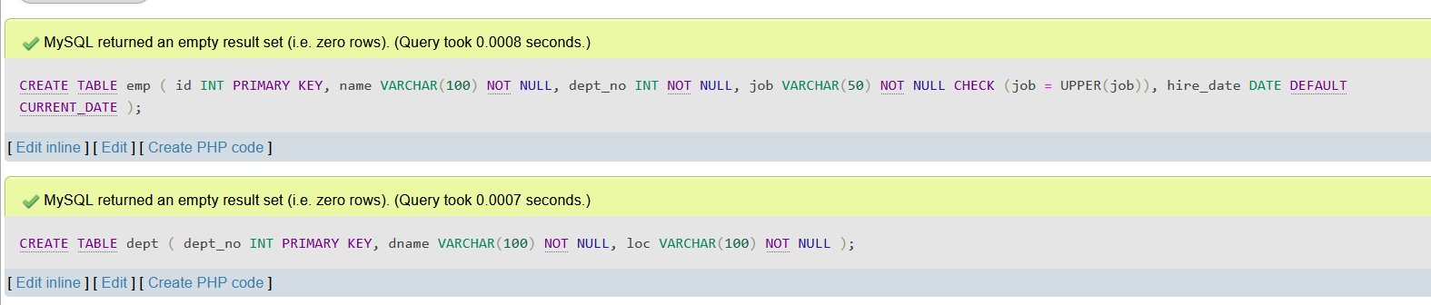

**2)** Modify the emp table to add three new columns: salary, manager, and commission, and to add a constraint on salary to ensure it is greater than 0

QUERY:

ALTER TABLE emp

ADD salary DECIMAL(10, 2) NOT NULL CHECK (salary > 0),

ADD manager VARCHAR(100),

ADD commission DECIMAL(10, 2);

**OUTPUT:**

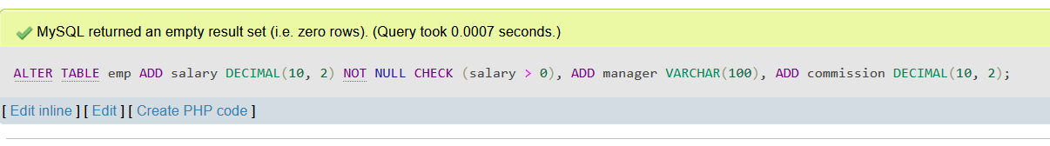

**3)** Insert data into the table

QUERY:

INSERT INTO emp (id, name, dept_no, job, hire_date, salary, manager, commission) VALUES

(101, 'Alice Johnson', 1, 'MANAGER', '2024-09-01', 80000, 'Michael Scott', 5000),

(102, 'Bob Smith', 2, 'SALESMAN', '2024-09-15', 95000, 'John Smith', 7000),

(103, 'Carol Davis', 3, 'CLERK', '2024-09-20', 60000, 'Emma Clark', 3000),

(104, 'David Wilson', 4, 'ANALYST', '2024-09-25', 85000, 'Sarah Connor', 4000),

(105, 'Eva Green', 5, 'SALESMAN', '2024-09-26', 55000, 'Paul Wright', 2000),

(106, 'Franklin Miller', 6, 'CLERK', '2024-09-30', 50000, 'Nina Adams', 1500),

(107, 'Grace Lee', 7, 'PRESIDENT', '2024-10-01', 120000, 'Olivia White', 10000),

(108, 'Henry Carter', 8, 'ANALYST', '2024-10-05', 110000, 'James Bond', 8000),

(109, 'Ivy Anderson', 9, 'SALESMAN', '2024-10-10', 70000, 'Emily Davis', 3500),

(110, 'Jack Brown', 10, 'CLERK', '2024-10-15', 45000, 'Martin King', 1000);

**OUTPUT:**

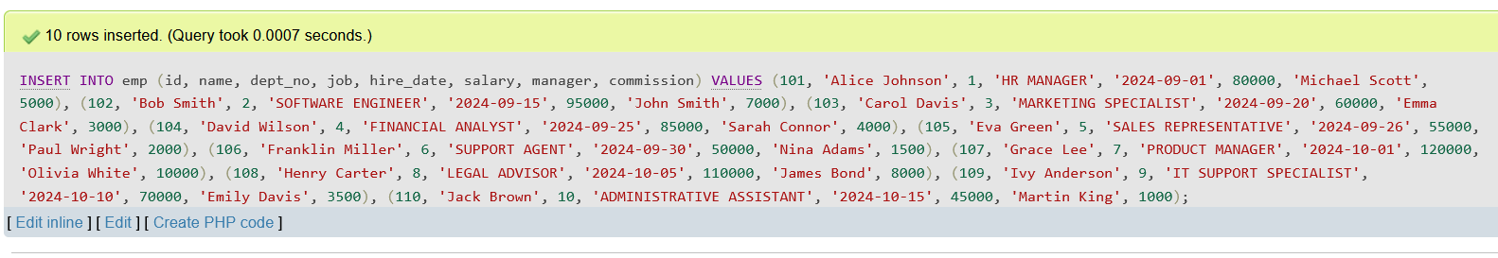

**4)** Retrieve all the table data

QUERY:

SELECT * FROM emp;

**OUTPUT:**

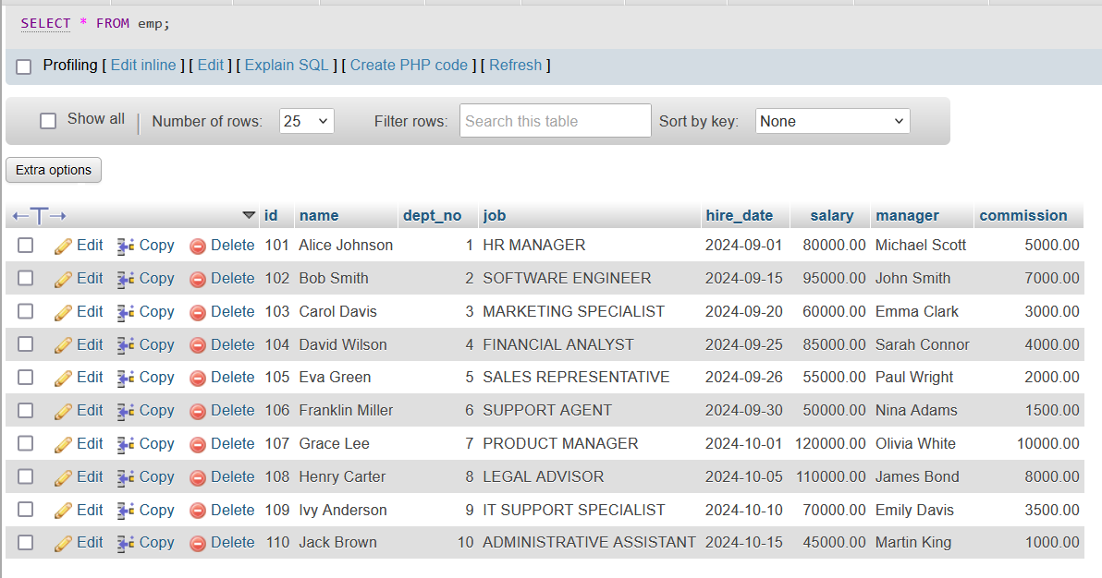

**4)** Delete row where id is 105

QUERY:

DELETE FROM emp WHERE id = 105;

**OUTPUT:**

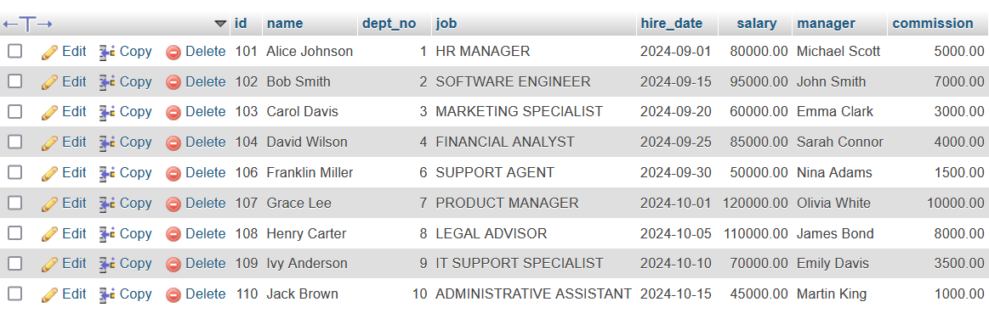

**4)** Delete or Drop table emp

QUERY:

TRUNCATE TABLE emp; [OR] DROP TABLE emp;

**OUTPUT:**

